# *The West Should Welcome Gaza Refugees*

## Europe and the U.S. accepted millions who fled earlier wars.

By Danny Danon and Ram Ben-Barak

Nov. 13, 2023 1:58 pm ET

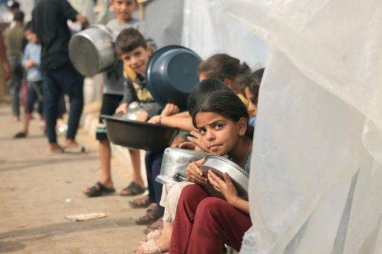Palestinian children who have fled their homes in the northern Gaza Strip wait for food in Khan Yunis in southern Gaza, Nov. 11. Photo: mahmud hams/Agence France-Presse/Getty Images

Hamas’s unprovoked terrorist attack on Oct. 7 has endangered not only Israel but the more than two million people who live in the Gaza Strip. Although Hamas won 2006 elections in Gaza and took control of the area from the Palestinian Authority the following year, the group has said that it bears no responsibility for the people living there.

On Oct. 15, Hamas operatives stole food and medical supplies from humanitarian trucks. The United Nations Relief and Works Agency reported the theft in a tweet, which it later deleted. But U.N. sources confirmed the theft to Israel’s Walla News, and Israel’s military liaison to the Palestinians confirmed that fuel and medical supplies went to Hamas.

Last month, the U.N. General Assembly adopted a resolution calling for an “immediate, durable and sustained humanitarian truce” and demanded that all parties allow the “continuous, sufficient and unhindered” provision of essential supplies and services into the Gaza Strip. As the war continues, however, U.N. resolutions are doing nothing tangible to help Gaza’s residents. It is imperative that the international community explore potential solutions to help civilians caught in the crisis.

One idea is for countries around the world to accept limited numbers of Gazan families who have expressed a desire to relocate.

Europe has a long history of assisting refugees fleeing conflicts. The wars in the former Yugoslavia displaced millions, most of them from Bosnia and Herzegovina. Germany, Austria and Sweden accepted large numbers. When the Kosovo war erupted, hundreds of thousands of Kosovar Albanians fled to neighboring Albania and the country now called North Macedonia. Germany, the U.K. and the U.S. also accepted refugees. European countries including Germany, Sweden and France have provided refuge to Syrians since the civil war started in 2011. Between 2015 and 2016, Germany alone admitted more than 1.2 million refugees and asylum-seekers, about a quarter of whom were Syrian.

Looking to these examples, countries around the world should offer a haven for Gaza residents who seek relocation. Countries can accomplish this by creating well-structured and internationally coordinated relocation programs. Members of the international community can collaborate to provide one-time financial-support packages to Gazans interested in moving to help with relocation costs and to ease refugees’ acclimation to their new communities.

Global organizations with experience settling refugees should facilitate the relocation of Gaza residents who wish to move to countries willing to accept them. We simply need a handful of the world’s nations to share the responsibility of hosting Gazan residents. Even if countries took in as few as 10,000 people each, it would help alleviate the crisis.

The international community has a moral imperative—and an opportunity—to demonstrate compassion, help the people of Gaza move toward a more prosperous future and work together to achieve greater peace and stability in the Middle East.

*Mr. Danon is a senior Likud member of Israel’s Knesset. He served as ambassador to the U.N., 2015-20. Mr. Ben-Barak is a Yesh Atid member of the Knesset. He served as a deputy director of the Mossad, 2009-11.*

<https://archive.md/PrU6U#selection-4407.0-4679.208>